PROJECT SRS DOCUMENT

DATE – Sunday,February 24,2013

SECRET CYBER INVESTIGATION AGENcY

Submitted to:

Prof Swathi J.N

-Naga Malleswara Rao(10bce0114)

-Saurav Mazumdar(10bce0274)

-Saketh P(10bce0495)

**Table of Contents**

**1.Aim ...................................................................................................................................**

**2. Project Overview ...........................................................................................................................**

2.1 User Stories/Problem Description ..........................................................................................

2.2 Scope

.....................................................................................

2.3 Process Model Identification & Scheduling

…………………………………………………………………………………………………………..

2.4 Key Constraints And Stakeholder Identification

**……………………………………………………………………………………………………………………………….**

**3. Project Schedule .............................................................................................................................**

3.1 Major Project Milestones ..............................................................................................

3.2 Work Breakdown Structure

.................................................................................................

3.3 PERT Chart for Project ................................................................................................

3.4 Gantt Chart for Project

……………………………………………………………………………………………..

3.5 Project Time Line Chart **................................................................................................……………………………….**

**4. Project Resource Requirements .....................................................................................................**

4.1 Hardware Requirements

………………………………………………………………………………………….

4.2 Software Requirements

**...................................................................………………………………………………………………**

**5. Risk Management ...........................................................................................................................**

5.1 Risk Management Strategy ...........................................................................................

5.2 Initial Risk List .............................................................................................................

1)Revision History:

2)Definitions, Abbreviations and Acronyms:

**3.)AIM :**

The following project aims to develop a scene software for a certain secret cyber agency.In this,we develop a web based application which interactively maps the design and functioning of an agency which monitors the activities in a city to keep the criminal cyber activities like phishing and username/password theft under control with a successful crime solving rate.Secret tracking officers are used to solve complex cases where an interactive system is maintained to ensure secure transfer of information between agency and its agents.This type of software has a wide scope in the future so that the government with the help of ministry and the agency can keep track and live with a crime free environment.

**4.)PROJECT OVERVIEW**  :

**4.1 Problem Description:**

In todays World,we need to ensure that hacking cannot be done on major sites such as the daily central shopping forums,e-commerce and Social Networking sites in general.So we implement a secret cyber investigation agency where we make secret officials called the TRACKERS who work on individual modules and cases that are assigned to them based on the complaints that they get from the users in the market who are attacked or thought they are a live target of any software mishap or cyber defaulting.3 things that hackers mainly concentrate on in this domain are

i)Credit Card Details

ii)Username/Password details

iii)Spam mail and Stalking(giving random mail and getting us to open sites which on opening give them profit and put virus into our system).

So,this is a project based to avoid the whole idea completely and as mentioned above,catch criminals with a very high crime solving rate.

We can use various modules like an online server,tracking supervisor,tracker,Phishers and a us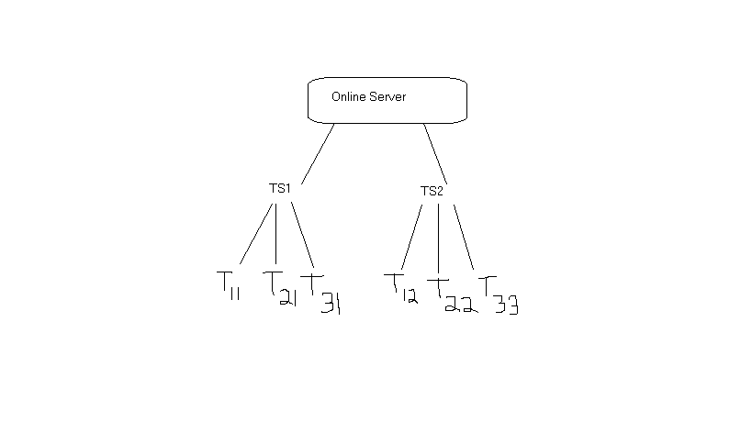

**4.2 User Stories:**

**Online server-**

a) Define the various domains in which the tracking team needs to be deployed

b) Depending on severity of the act of phishing, the tracking team must take necessary remedial

measures.

c) Forum for users to post their problems

d) Updates the firewall and security boundaries laid down by the different websites

**Tracking supervisor-**

1. Maintains the database of the listed attackers who have been previously caught on sites like rapidshare, facebook, myspace etc.
2. Security requirements – login with access code, proper logs of tracker activity maintained( tracker may turn rogue)

**Tracker-**

1. Uploads the IP, MAC address, owner, billing information, browsing history of hacker
2. Encrypted data needs to be sent to the tracking supervisor (Diffie-Hellman , RSA algorithm can be applied) to prevent 3rd party intervention

**User-**

1. Provides suspect usernames
2. Filing cases if attacked by a hacker or is a prey of phishing, directly contacts online server

**4.3Scope :**

This software has a very wide scope in future as with time technology is on the uprise and an efficient,fast and secure mode of communication needs to be provided so that the government with the help of the ministry and agency of cyber safety can provide a secure browsing system environment.

**4.4 Process Model Identification & Scheduling :**

Our desired project has the following functional requirements:

1. High reliability
2. Risk analysis and management plan
3. Secure data transfer, encryption module is used extensively
4. Fast upload of data
5. Minimum resource constraint (memory, cost and power)

Keeping in mind the above requirements, we see that the incremental SDLC model is best suited for the following reasons:

**Incremental Delivery Model:**

1. Requirements are well defined and well known beforehand
2. The model provides flexibility and provides the privilege to update the software and database
3. Customer (Online server) has the privilege to respond to each build. Once a code package is complete the customer checks and suggest changes
4. Incremental SDLC provides a proper risk analysis plan which helps to increase level of security or provide prompt event handling in case of system handling
5. Highest priority services are delivered first,the most important system services receive the most testing.
6. Here,there is a very lower risk of overall software failure.Since,each module is developed separately.

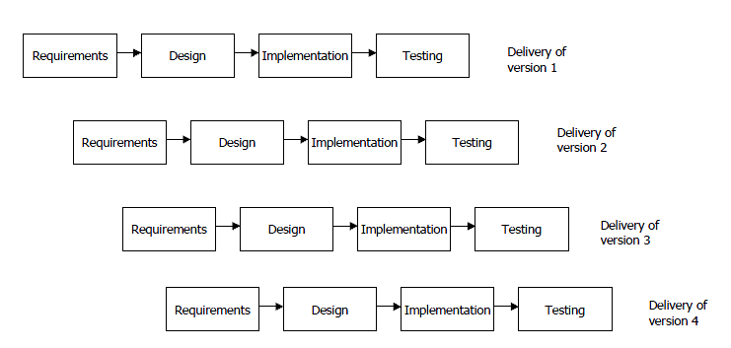 INCREMENTAL MODEL FIGURE

**Justification For Not Choosing Other Models-**

**Rapid Prototyping-**

Unstable model,Poorly implemented,customers are usually non-technical.

**Waterfall-**

Integration is a problem,modules can’t be added later on and requirements should be known upfront.

**V-shaped -**  
No risk analysis activities,can’t handle concurrent events,no iterations or phases.

**Code and fix-**

No deadline,no resource planning.

**Spiral-**

Limited idea about requirement,tedious process followed to accommodate small changes.

**FLOW CHART OF INCREMENTAL MODEL:**

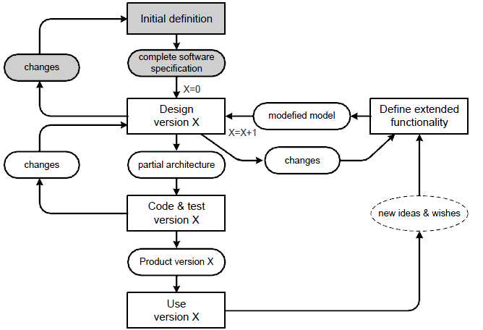

**4.4)Key contacts and Stakeholder Identification:**

DIRECT CONTACTS :

|  |  |  |
| --- | --- | --- |
| NAME | REGISTRATION NUMBER | PHONE NUMBER |
| Naga Malleswara Rao | 10BCE0114 | 07200301665 |
| Saurav Mazumdar | 10BCE0274 | 08754259905 |
| Saketh P | 10BCE0495 | 09790010884 |

OTHER INDIRECT CONTACTS (may include ourselves) :

1. Administrator(Online Server).
2. Database Manager.
3. System Engineer.
4. Tracking Supervisors.
5. Trackers.
6. Analyst.
7. Users(complaint lodgers).
8. Phishers.
9. Advertizing team.

**5 PROJECT SCHEDULE :**

**5.1 Major Project Milestones:**

|  |  |  |  |  |
| --- | --- | --- | --- | --- |
| **Milestone** | **Estimated Start** | **Estimated End** | **Estimated Hours** | **Number of Days** |
| Problem description and stakeholder identification | 8/2/13 | 18/2/13 | 33 | 11 |
| Srs discussion | 19/2/13 | 1/3/13 | 33 | 11 |
| Setting up online server | 2/3/13 | 12/3/13 | 33 | 11 |
| Testing functionality | 13/3/13 | 15/3/13 | 9 | 3 |
| Creating manger’s UI and message passing | 15/3/13 | 19/3/13 | 15 | 5 |
| Testing delivery of messages | 20/3/13 | 22/3/13 | 9 | 3 |
| Creating tracker’s UI and reporting | 22/3/13 | 2/4/13 | 36 | 12 |
| Testing the system | 3/4/13 | 7/4/13 | 15 | 5 |
| Creating online forums | 8/4/13 | 11/4/13 | 12 | 4 |
| Testing and resolving issues | 12/4/13 | 27/4/13 | 48 | 16 |
| Installation and going online with  Maintenance | 27/4/13 | ------ | ------- | -------- |

**5.2 Work Breakdown Structure:**

**5.3 PERT Chart : (Activity Network Graph)(Performance Evaluation review Technique)**

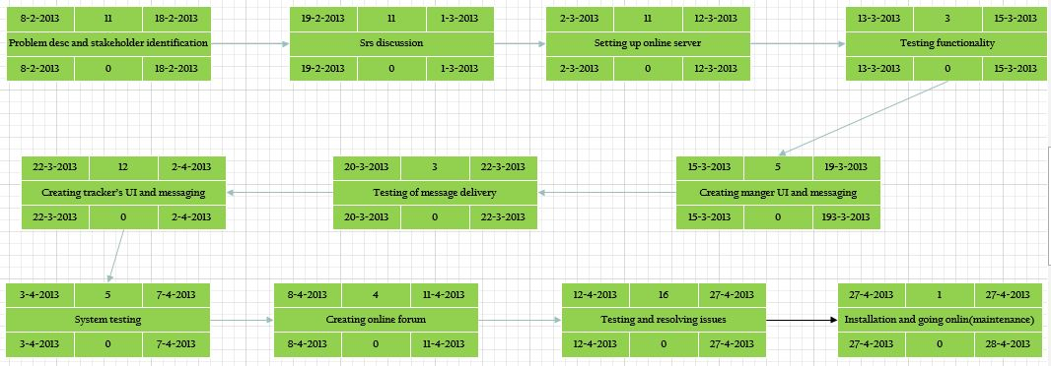

* 1. **Gantt Chart : (Bar Graph)**

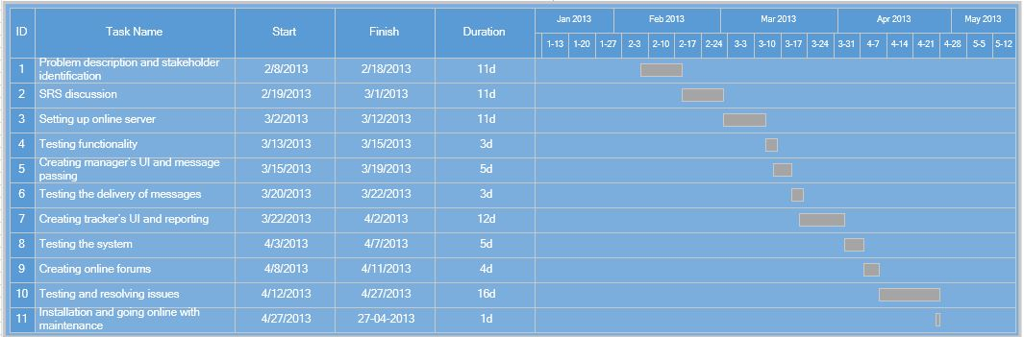

* 1. **Timeline Chart:**

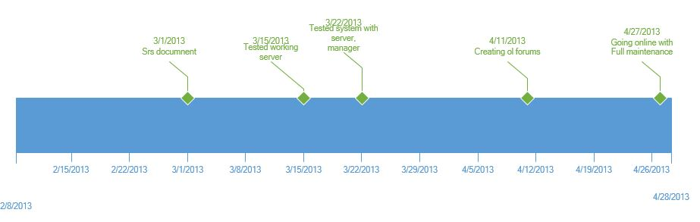

1. **PROJECT RESOURCE REQUIREMENTS:**

**6.1 HARDWARE RESOUCE REQUIREMENTS:**

* Minimum RAM 512 MB
* Minimum disk Space : 500 GB
* Processor Intel Core 2 Duo 2.4 GHz Minimum
* Server for Trackers.

**6.2 SOFTWARE RESOUCE REQUIREMENTS:**

* Windows XP(service pack).
* Oracle 11G.
* .Net Framework
* Rational Rose Enterprise Edition.
* Microsoft Visio 2013.
* Creately.com(WBS).
* Agro UML.
* Browser(internet explorer 6.0 or above).

**7. RISK MANAGEMENT:**

7.1 **Risk Management Strategy:**

Priority in which the data is hacked is based on the Weight of the customers complaint,in such a way that (Credit card detail retrieval> facebook account getting hacked). The precedence is already predefined and we have to have the maximum no. of necessary resources and not resources that are used for luxury for the trackers,to avoid any kinds of business risk.

7.2 **Initial Risk List:**

|  |  |  |  |  |
| --- | --- | --- | --- | --- |
| **Risk Type** | **Risk Probability(H,M,L)** | **Risk Name(brief Description)** | **Mitigation Strategy** | **Effect on Product** |
| Product | H | System Failure or the Server going low. Then the phisher can pounce on the sites. | Proper Backup and Restore | Severe |
| Project | H | Hierarchial Fault(Since 1 person has a control over the other,if someone gets lazy all the sub-trackers are affected). | Employment based on trust,qualification than just recommendation. | Adverse |
| Business | L | Insufficient number of resources. | Provide adequate number. | Moderate |
| Product | Very Low | Phisher tries to hack through the online server. | Doesn’t happen usually.Only due to negligence | Catastrophic |
| Project | M | Database gets corrupted. | If there is a problems like redundant data storage. | Insignificant |
| Project | L | Tracker can go rogue. | We will make sure it doesn’t happen. | Very catastrophic. |
| Business | M | Insufficient number of trckers. | Other company’s Agency may have more trackers. | Loss. |

8.)User Requirements:

->Functionalities.

->User Specifications.

9)System Requirements:

Requirement Gathering:

-> Traceability matrix(source,requirements affected and modules developed)

**-> Non-Functional Requirements**

**\*Separate explanations.**

**\*Constraints.**

**->Functional Requirements.**

**Object Oriented Analysis and design**

**- Use Case diagrams(3-4)**

**- Explanations(individual)**

**-ER diagram**

**-State transition diagram**

**-Activity diagram**

**-Class diagram**

**-Sequence (Collaboration)**

**-Architecture diagram**

**\*Architectural Model identification and Explanation**

**->System Structuring.**

**->Control Models.**

**->Modular decomposition.**